**Ideation Phase**

**Define the Problem Statements**

|  |  |
| --- | --- |
| Date | 17 June 2025 |
| Team ID | LTVIP2025TMID41713 |
| Project Name | TrafficTelligence: Advanced Traffic Volume Estimation with Machine Learning |
| Maximum Marks | 2 Marks |

**Customer Problem Statement Template:**

Create a problem statement to understand your customer's point of view. The Customer Problem Statement template helps you focus on what matters to create experiences people will love.

A well-articulated customer problem statement allows you and your team to find the ideal solution for the challenges your customers face. Throughout the process, you’ll also be able to empathize with your customers, which helps you better understand how they perceive your product or service.

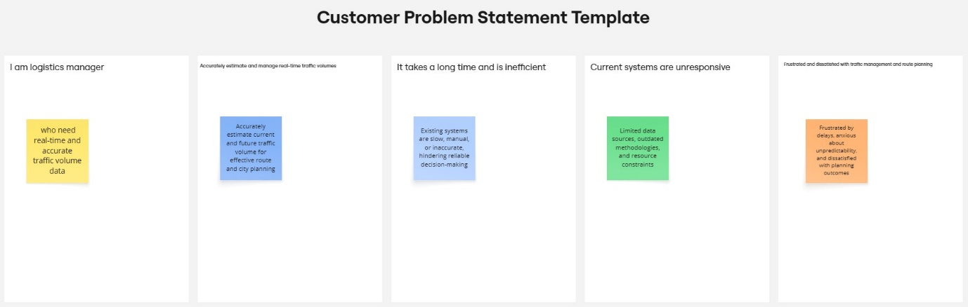

Reference: <https://miro.com/templates/customer-problem-statement/>

|  |  |  |  |  |  |
| --- | --- | --- | --- | --- | --- |
| **Problem Statement (PS)** | **I am (Customer)** | **I’m trying to** | **But** | **Because** | **Which makes me feel** |
| PS-1 | A city planner or commuter | Accurately predict and manage current and future traffic volumes | The data I receive is often outdated or incomplete | Current systems rely on slow, manual reporting methods | Frustrated, powerless, stressed |
| PS-2 | A logistics manager or daily traveller | Plan optimal delivery routes or daily commutes | Traffic volumes are unpredictable and rarely automated | Traffic systems don’t integrate real-time, diverse datasets | Anxious, dissatisfied, uncertain |